Newsletter 3rd Qtr. 2020 October

In Memory of Kenny and Melissa Comstock:
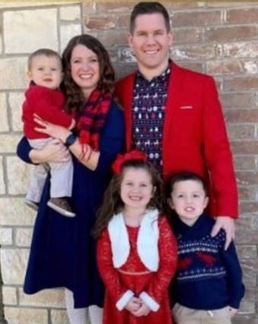
It isn’t that often that an Executive Pastor personally takes on ministry to prisoners as a major emphasis of his church. When it does happen, for those of us who labor in the support of church outreach to the incarcerated, they are thought of as jewels to be treasured. We treasured Pastor Ken. Crossings Church in Odessa, Texas was a model for Alpha Prisoner Reentry. Not only did he establish a church plant inside prison, but he was also actively involved in leading other pastors in the area to understand the importance of the church in community reunification for those who were returning home from prisons. His heart was filled with the love for others and just an all-around good guy.
On September 24, 2020, Kenny, Melissa, and their family, while on the way to Ruidoso, NM for a fun family weekend together, were hit head on near Tatum, New Mexico. Kenny and Melissa both died from the injuries sustained in the car accident. However, by a miracle of God alone, all three of their children survived; Natalie (6), Camden (4) and Carver (1). Words can not express our grief.

Alpha Is Back Inside:
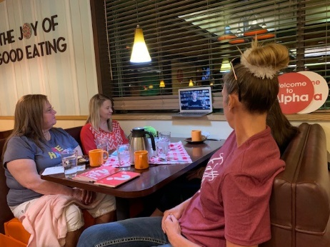
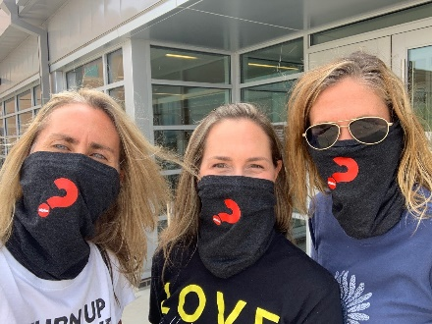
With the Covid 19 Pandemic came elimination of all on-site volunteer programs in virtually all federal, state, and local prisons and jails. Many will not resume normal activities until this spring. Volunteers are integral to effective facility management as well as to the sustained mental health of the inmates. Closures have been devastating to both. Not to mention the frustration of those thousands of volunteers who know they have been called by the Lord to go visit the prisoners. Many Alpha volunteers are still supporting the prisons by writing letters, providing hygiene supplies, and encouraging staff outside of the fences. It was truly a blessing for many reasons to hear the Alpha Team, led by National Prison Advisor Jen Ortmann, was allowed back inside the Douglas County Jail in Denver with the continuation of 2 Alpha courses for women and 2 for men. Jen and her team have also initiated Pie, Coffee and Alpha at the Village Inn every Thursday at 6:30 PM for those men and women who have been released from jail who want to lean into the Christian faith and receive encouragement and support in their successful return to their community. How great is that!!!

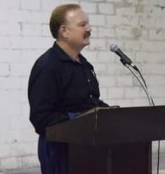
We Call Him Chap:
There are so many people during this time of the pandemic going above and beyond the call of duty. They are truly an inspiration. One such group of people who have had little recognition is our prison and jail Chaplains. During our International Prayer calls for Chaplains we heard the frustration and fatigue in their voices but also the devotion to keep going. While there are job descriptions for prison and jail Chaplains, they are called upon often to go outside their assigned duties in support of the needs for inmates, staff, and the organization. We salute these men and women by highlighting one such person in particular who we affectionately call Chap. Chris Athey former Texas Department of Criminal Justice Chaplain has served in 8 Texas prisons since 1993. As the Chaplain of the Estes Sanders Unit near Dallas, he supported the establishment of the Alpha Faithbased Dorm and Reentry Initiative. Frankly, it would have been impossible to accomplish our mission without him. He recently retired due to health reasons but has continued to serve the men on the dorm at Estes as a Volunteer Chaplain. His dedication is so representative of the thousands of Chaplains in our prisons and jails. Thank you Chap and God Bless you.

Alpha On-Line Goes To Prison:
Truly through the Lord there is always a way. When the pandemic hit, churches closed, and Alpha courses were also suspended. Within a matter of weeks Alpha staff rose to the occasion by creating the ability for Alpha groups to continue to meet on-line through zoom calls. To date over 3,600 Alpha On-Line courses have been held representing over 2,000 churches. Isn’t that amazing and a testament to how the Lord continues to bless our efforts. Prisons and jails have yet to fully utilize the technology of the internet for inmate participation. Many of the reasons are security oriented although with new adaptations these concerns are starting to be eliminated. Through their years of providing Alpha at the Tecumseh State Correctional Institution in Nebraska, Jodi Myer, Alpha Director for Nebraska proposed conducting an Alpha On-Line. It was approved! Our first prison on-line course in the country. Jodi is leading the course and reports that it is going as planned and the inmates do so appreciate being involved. We are expecting to expand this offering to other facilities around the country and if you are interested in learning more contact: JackCowley@alphausa.org Thank you Jodi for your vision and dedication.

It Is “that” Time Of The Year:
The Prisons & Reentry Division for Alpha USA is funded solely through partnerships with donors. Not unlike other not for profit ministries the end of the year is the time when we conduct our major fund-raising efforts. I’m already receiving letters, emails and phone calls asking if we would donate to various causes! There are so many worthy causes out there to consider. I would be thankful if Alpha for Prisons and Reentry is one that you would consider. We provide all our materials for free and assist churches with training and technical support to build and sustain Alpha courses in criminal justice facilities in every state. We work with Chaplains in approving Alpha for their facility and assist those ex-offenders in finding a welcoming church upon release. All this to introduce Christ to offenders in order that we might have safer communities in which to live. I can assure you that we are thoughtful stewards of funds provided by our partners. We are making a difference. If you would, please prayerfully consider it. Giving online is easy by going clicking on the give button and selecting “National Ministry-Prisons”. You might also consider a providing a monthly or reoccurring donation. Thank you for thinking of us in this way.
Picture by: Graham Covington

