Newsletter 4th Qtr. 2020-December

2020 In The Rear-View Mirror
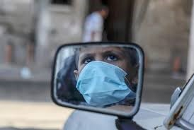
Thank the Lord the year is about over, RIGHT? This is one situation that you don’t have to explain to anyone regardless of where you live or what you do. 2020, the year of the virus. Looking with hope to 2021. You know though even with the pandemic and the struggles that it brought, we have been able to make progress in supporting offenders and the criminal justice system in ways that we never dreamed of doing before. With all prisons and jails closed to volunteers and family members we had to get creative in continuing our work in supporting the Spiritual growth of those incarcerated, encouraging correctional staff and engaging our volunteer partners. From holding International Prayer zoom calls with correctional Chaplains worldwide, developing digital content for institutional programming, piloting Alpha On-Line for offenders in prison to conducting volunteer prayer calls, we have not gone quietly into the night due to the pandemic! While we look forward to prisons/jails opening again for Alpha and Reentry programming, we thank God for the opportunities that presented themselves this year and the determination He gave us to meet the challenges. We want to thank our prayer partners, organizational partners, volunteers, and Alpha USA Administrative Staff as well for assisting us in our efforts. It will be a year to remember.

Alpha Celebration at Tecumseh State Correctional Institution
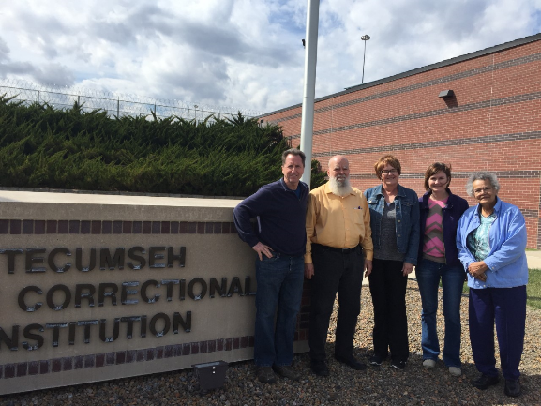
As we have reported, Alpha Nebraska Regional Director, Jodi Meyer started the first Prison Alpha On-Line Zoom course in the nation. Most prisons still do not allow internet connections to be used in this manner by offenders. We hope that with the success Jodi and the Tecumseh staff have witnessed from this pilot that more prisons across the country will provide Alpha On-Line to the prison population. While we look forward to the day when Alpha volunteers will be allowed to return for “in-person Alpha” there are still prisons/jails where volunteers are limited. There will always be a need for Alpha On-Line in prisons. This month the offenders at Tecumseh celebrated their completion of Alpha. During the celebration many were provided the opportunity to share their experience. Here is what a few had to say,
“This has given me hope. I realized God has never given up on me”.
“Now on the phone I talk with my son about church”.
“People said, something has changed about you and I tell them it’s God”.
“Alpha taught me how to teach others who come to me asking questions about God.”
Thank you, Jodi, for your vision during this time of crisis in our prisons/jails. We look forward to following your example by establishing Alpha On-Line in other prisons/jails around the country. That will be a part of our Division Strategy for 2021.

Christmas in Prisons/Jails
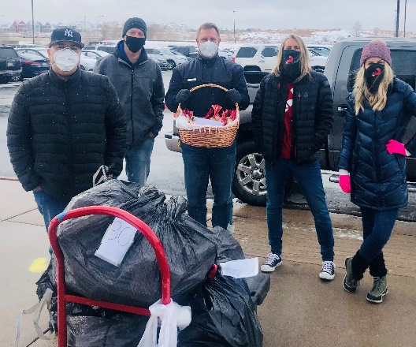
Alpha is about relationships; providing the opportunity for our Alpha guests to feel cared for regardless of where they currently are in the world. The objective of course to let them know though the Alpha Hosts that God loves them. So, it is as well in prisons/jails. As you can imagine particularly during this time of Covid when most prisons/jails are not allowing family visits that Christmas can be a very difficult time for those who are incarcerated. Many Alpha volunteers around the country are aware of this and are providing offenders with the understanding that they are not just cared for during an Alpha Course but all the time. Like the Denver Alpha Team, under the leadership of Alpha National Prison/Jail Advisor Jen Ortmann, this year for Christmas Jen and her team are delivering 1200 Alpha Blessing Bags to the women at the Denver Correctional Facility. If offenders truly understand that others care for them, as does The Lord, then they may begin to care for themselves and others, which leads to doing no harm to themselves or others. Thanks to Jen and her Team as well as the other Alpha Teams around the country who are providing “the Alpha way” to those who are incarcerated. You are truly making a difference.

Join us for a Night with The Alpha Conference

This year has been challenging and unpredictable in so many ways. And all the while, you've poured into your church, your family, your community, and those far from Jesus. We want to pour back into you. On Thursday, January 28, 2021, we're hosting a free virtual evening together to do just that. We'll share in worship, times of prayer, see stories of transformation, and hear how churches across the nation have responded to the challenges and opportunities of 2020. Our prayer is that this night will refuel, encourage, and inspire you to press on in the unique ways you serve God and his people. Our special guest will be Nicky Gumbel, Pioneer of Alpha and Vicar at HTB London. Please register at https://alphausa.org/the-alpha-conference-2021 Hope to see you there!!!

Would You Consider Becoming a Monthly Partner

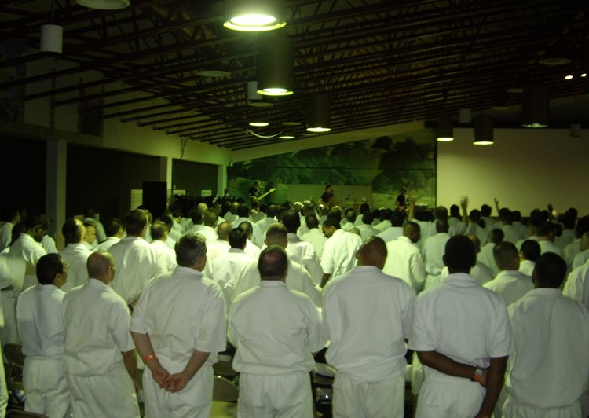
Giving is such a personal motivation. When it comes to supporting Alpha for Prisons some people say that they can’t be the ones going into prisons, so they support us because of Christ’s reference to caring for those in prison (Matthew 25:43). Others say they support our work because they have either been in prison/jail, had a loved-one incarcerated or is a victim of crime and didn’t want others to experience their pain. Katherine said she choose to be a monthly partner because she was concerned for those involved in the criminal justice system and from her personal experience knows that Alpha can change lives. Our Alpha Prison Team is so encouraged when people partner with us not just in that they support our work financially but that they share our quest for seeing lives changed through a relationship with Jesus. Whether it be $5.00 or $500.00 each month we rejoice that people share our passion for our work with prisoners and the criminal justice system. Thank you for considering joining with us on a plan of monthly financial and prayerful partnership. Follow the link https://alpha.givingfuel.com/give and select “National Ministry-Prisons” in the Select Fund drop down box. You may also send checks made to Alpha USA Prisons to Alpha USA, 1635 Emerson Lane, Naperville, IL 60540.

